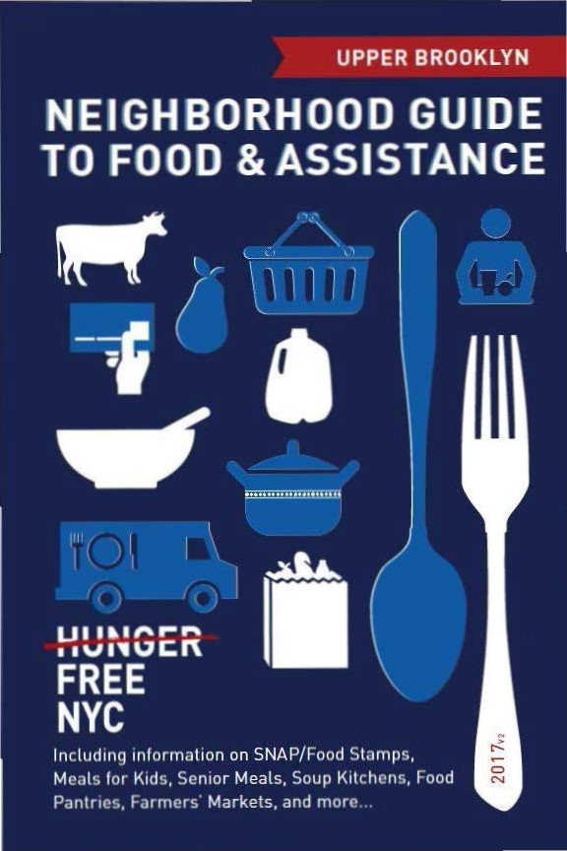

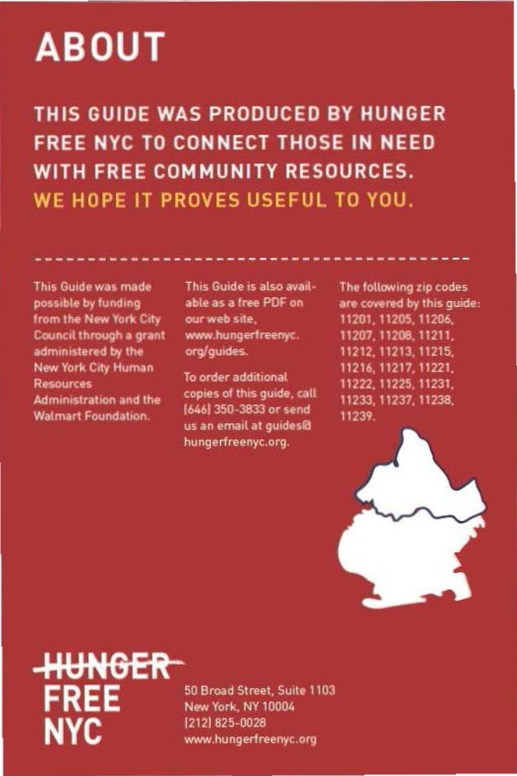

CON TEN TS

Food Stam ps/SNAP 4
Cl) Food fo r Kids 8
e Em ployme nt & Tra in i ng 12
<D Senior Mea ls 13
0- Soup Kitch ens & Food Pantries 14
e From the Farm 30
Map of Locations 34
Other Assista nce 42
Emergency N um bers 43

Neighborhood Guide to Food andAssistance - Upper Brooklyn Edition
 SNAP/
FOOD STAMPS
SNAP benefits, the new name for food stamps, can help put healthy food on the table by providing monthly assistance
to purchase food at authorized grocery stores and farmers' markets. Benefits are provided monthly th rough a plastic benef it card, similar to a de bit or credit card.


EBT
Stands for Electronic Benefit Transfer. It's the system the goverment uses to disburse benefits.

SNAP
Stands for
Supplemental Nutrition Assistance Program. "SNAP benefits· is the same thing as "food stamps."
WHAT SHOULD I KNOW?
m Employment does not interfere with getting SNAP. Even if you are working, but
earning lowwages, you may be eligible.
m Average SNAP benefits a re over $100 per person per month, and $250 or more
for families. That mea ns that SNAP benefits for the average family receiving them totals more than $3,000 worth of food support each year.
m Farmers' markets often accept SNAP
benefits, so you ca n purchase fresh produce
and food·producing seeds and plants using your benefits. For a complete list of farmers' markets that accept them, see page 30.

IINeighborhood Guide to Food and Assistance ·Upper Brooklyn Edition

AM I ELIGIBLE?


Eligibilit y is based on household size, income, expenses and other factors. Households have to meet income tests to receive benefits, but households that have members w ho a re disabled or elderly [60 or older), or have out-of-pocket expenses for
child care or dependant care, ca n have hig her incomes a nd

still be eligible.
A_..,,.. _.

NUMBER OF PEOPLE IN HOUSEHOLD
MONTHLY INCOME LIMIT (PRE-TAXES] 1
MAX. MONTHLY SNAP BENEFITS2

1 $1,307 $192
-----------------------------------
2 $1,760 $352

3 $2,213
4 $2,665
$504
$640

Each additional household member
+$453
(approximately)
+ $144
(approximately)

11n effect
10/1/16 - 9/30/17.

21n effect
10/1/16 - 9/30/17.

If you meet the above income qualifications, it doesn't matter how much money you may or may not have in countable resources. In other words, you can save money for education , a home purchase, or retirement a nd still receive SNAP benefits.

Neighborhood Guide to Food andAssistance - Upper Brooklyn Edition II

IMMIGRANT ELIGIBILITY

Legal immigrants can often receive SNAP benefits if they:
- have lived in the country for 5 years or more; or
- are children (under age 18).
Ineligible immigrant parents can still receive benefits for their children even if a parent does not qualify.
Certain non-citizens, such as those admitted for humanitarian reasons, may also be able to receive benefits.
Immigration status is not negatively affected if you apply for or receive SNAP benefits.

HOW TO APPLY

Apply at Select Community Organizations
1

Call either of the below numbers to see if you may be eligible for benefits. If so, you’ll be offered an appointment at an agency in your community, where you’ll receive help in submitting your application electronically.
Hunger Free NYC
646 355 1475 & 646 350 1104

Neighborhood Guide to Food and Assistance - Upper Brooklyn edition
6

ACCESSNYC
2
SNAP/FOOD STAMPS

Apply online at: www.nyc.gov/accessnyc

Visit Your Local HRA Office
3

Apply at a SNAP office near you:
- Williamsburg SnAp Center
30 Thornton St., 4th Floor, 11206
718 722 8013
Mon-Fri 8:30am-5pm
- north Brooklyn SnAp Center 500 Dekalb Ave., 4th Floor, 11205 718 722 8013
Mon–Fri 8:30am–5pm
- Fort Greene SnAp Center
275 Bergen St., 1st Floor, 11217
718 722 8013
Mon–Fri 8:30am-6pm, Sat 9am–5pm
- east new york SnAp Center 404 Pine St., 1st Floor, 11208 718 722 8013
Mon-Fri 8:30am-5pm

You can also call 718 557 1399 to find a SNAP office near you and for information about qualifications, guidelines, and applications.

Neighborhood Guide to Food and Assistance - Upper Brooklyn edition
7
FOOD FOR KIDS
WOMEN, INFANTS & CHILDREN
WIC is the Women.Infants & Children Program.
QUICK FACTS
l:l WIC is for low-income pregnant women, breast-feeding women. and women with children under the age of five.
l:l You can work and still get WIC.
l:l You can continue to get cash assistance or SNAP benefits/food stamps while receiving WIC.
l:l You can get WIC even if you are undocumented or not a citizen.

HOW TO APPLY
To find the WIC off ice nearest you call 800 522 5006, call 866 3-H UNG RY or visit these local WIC off ices.
- North Brooklyn Health Network at Greenpoint 875 Manhatta n Ave.. 11222
718 630 3224/3223
Mon 11:30a m-8pm, Tue-Fri 8:30am-5pm
- North Brooklyn Health Network at Williamsburg 279 Graham Ave., 2nd Fl. 11211
718 963 784517836
Mon 11am-7pm; Tue-Fri 8:30am-4 :30pm 14th Fri closes 12:30pml
- Wyckoff Heights Medical Center -Williamsburg 168 Division Ave., 11211
718 384 6161
Mon 8:30am-6pm. Tue-Fri 8:30am-4:30pm
- Opportunity Development Association of Williamsburg 12 Heyward St., 11211
7188521917
I
Mon-Thu 9am-5:30pm, Fri 9am-1pm
Neighborhood Guide to Food andAssistance·Upper Brooklyn Edition
- northern Brooklyn Health network - Woodhull Medical Center
760 Broadway, 11206
FOOD FOR KIDS
718 963 8559
Mon, Wed, Fri 8am-5pm; Tue, Thu 8am-7pm; 1st, 3rd Sat
8:30am-3:30pm
- Wyckoff Heights Medical Center 316A Himrod St., Suite 1, 11237 718 963 6471
Mon, Wed, Fri 8:30am-4:30pm; Tue, Thu 8:30am-7pm
- nyU lutheran - park Slope WIC
220 13th St., 11215
718 832 5986
Mon-Wed, Fri 9am-5pm; Thu 10am-6pm
- Brooklyn Hospital Center - Dekalb WIC
121 Dekalb Ave., 11201
718 250 8126/8124
Mon, Wed 9am-4pm; Tue, Thu 9am-6pm; Fri 8:30am-3:30pm
- north Brooklyn Health network at Cumberland
100 North Portland Ave., 11205
718 260 7676
Mon-Fri 8am-4pm, Wed until 7pm by appt.
- Bedford Stuyvesant FHC WIC program
20 New York Ave, 1st Floor, 11216 718 857 4268
Mon, Thu 9am-7pm; Tue 9am-5pm; Wed 8am-5pm; Fri 9am- 3pm; Sat by appt. only
- public Health Solutions Bushwick WIC Center
335 Central Avenue, 11221
718 919 0044
Mon 11am-6:30pm; Tue-Sat 8:30am-4pm
- Brooklyn Hospital Center - Bedford Stuyvesant
1606 Fulton St., 11213
718 773 4126
Mon, Wed 9am-5pm; Tue, Thu 9am-7pm; Fri 8:30am-4pm; Sat
9am-4pm (except 5th Sat)

Neighborhood Guide to Food and Assistance - Upper Brooklyn edition
9
- Brooklyn Hospital Center - Crown Heights
535 Empire Blvd., 11225
718 467 0010
Mon, Wed 9am-4:30pm; Tue, Thu 9am-6:30pm; Fri 8:30am-3pm
- BMS life and Wellness Center
408 Rockaway Ave., 11212
718 345 6366 ext 6649
Mon 8am-4:30pm; Tue, Wed 8am-3pm; Thu 7am-3pm; Fri 8am- 12pm; 2nd, 4th Sat 9am-12pm (for working parents only)
- BMS @ Genesis
360 Snediker Ave., 11207
718 345 5000
Mon, Wed 10am-1pm, 2pm-3:30pm
- east ny Diagnostic & Treatment Center WIC program
2094 Pitkin Ave, 11207
718 240 0470
Mon, Thu 8:30am-4pm; Tue 8:30am-7pm; Wed 8am-4pm; Fri
8:30am-3pm; 1st Sat 8:30am-3pm
- Brookdale Family Care Center new lots
465 New Lots Ave., 11207
718 240 8950
Mon-Fri 8am-5pm (Thu until 7pm), Sat 8:30am-4:30pm
- BMS Hubert A. Morrell early Childhood Academy
921 Hegeman Ave., 11208
718 345 6366
Tue, Thu 10am-1pm, 2pm-3:30pm
- Jamaica Hospital - MediSys east new york
3080 Atlantic Ave., 11208
718 647 0240
Mon-Fri 8am-4:30pm, Sat 7:30am-2pm

Neighborhood Guide to Food and Assistance - Upper Brooklyn edition
10
SCHool & SUMMer Me Al S
FOOD FOR KIDS
SFSp is the Summer Food Service Program, also known as Summer Meals.
QUICk FACTS
During school, free breakfasts are available to all children regardless of income, with no paperwork required.
Many public school students are also eligible for free or reduced price lunch. An application may be required.
Eligibility for school meals is not impacted by immigration status.
In June, July and August, lunch and breakfast are served for free to all children under 19 at many public schools, houses of worship, recreation centers, and community centers - no application or registration required.
Visit www.schoolfoodnyc.org for more information about school breakfast, school lunch, and summer meals. For nearby summer meals sites, text FOOD to 877-877, call 311, or call the National Hunger Hotline at 866 3-HUNGRY.

Neighborhood Guide to Food and Assistance - Upper Brooklyn edition
11
A JOB TRAINING &
RESOURCES
Certain individuals may be required to be employed, seeking employment and I or enrolled in a tra ining program in order to receive SNAP benefits.

EMPLOYMENT & TRAINING

Visit the follow ing sites to find out more about training and education programs across the city:

www1 .nyc.gov/htmVsbs/wf1/html/develop/develop.shtml www1 .nyc.gov/site/hra/help/types-trai ning-ed ucation.page

IINeighborhood Guide to Food and Assistance - Upper Brooklyn Edition


SENIOR MEALS

MEALS AT SENIOR CENTERS
Senior centers often serve meals for older people. Some centers offer free meals, oth ers ask for a small contribution !from fifty cents up to a few dollars!. This contribution may be voluntary or required. Senior cen ters and other sites with food for seniors are marked with • in the Soup Kitchens and Food Pantries section.
FIND YOUR LOCAL SENIOR CENTER
Call 311 and be prepared to provide your ZIP code to the operator.

MEALS- O N-WHEELS PROGRAM
If you are homebound and over the age of 60, you can receive home-delivered meals up to 7 days a week. Household income does not affect eligibility.
HOW TO APPLY
To request meals-on-wheels service , call your Local case management agency.
To find the appropriate agency, contac t the Citymeals-on-Wheels' Program Department at 212 687 1234 or the National Hunger Hotline at 866 3-HUNGRY.
Neighborhood Gulde to Food andAssistance - Upper BrooklynEdition

SOUP KITCHENS OFOOD PANTRIES


Agencies listed as soup kitchens provide prepared meals during
their listed serving times, while agencies listed as food pantries provide bags of food lo be prepared at home.
While we try to keep this list as accurate and up-to-date as possible, we recommend calling the agency before going to confirm their schedule.Some agencies require a referral, ID, or proof of address. To confirm, contact the agency directly, call the NYC Emergency
Food Lme at 866 888 8777 or call the National Hunger Hotline at 866 JHUNGRY.Agencies marked with are semor centers and/or provide food specifically for seniors.
GREENPOINT,WI LLIAMSBURG, BUSHWICK
11222, 11211.11206, 11237
- Greenpolnt Reformed Church 136 Milton Street, 11222
718383 5941
Soup Kitchen :Wed 6pm-7pm Food Pantry :Thu 8am-1l am ID preferred for food pantry.
- Southside United HDFC [Los Sures) 145S. 3rd St., Basement Office. 11211 718 599 1940
Food Pantry:Tue 9am-5pm
- St.John 's Bread and life Mobile Soup Kitchen - Division &
Marcy
240 Division St. & Marcy Ave.. 1121 1 Mobile Soup Kitchen:Wed 9:30am- 11am
IINeighborhood Gulde to Food andAssistance Upper Brook yn EdiUon
- Transfiguration Church 280 Marcy Ave., 11211 718 782 8181
PANTRIES & KITCHENS
Food pantry: Mon-Fri 9am-12pm
Photo ID required for registration (at 250 Hooper St). Food provided once a month. Serves clients from 11211 and 11206.
- Act of Faith Ministries
141 Manhattan Avenue, 11206
718 570 8277
Food pantry: 1st, 3rd Thu 12pm-2pm
- Trinity Human Services Corp. 153 Johnson Avenue, 11206 718 388 3176
Food pantry: Tue-Fri 9am-12pm (come early to line up), 1pm- 4pm
ID and proof of address required.
- City Harvest Bed-Stuy Mobile Market
Handball court of the Tompkins Houses on Myrtle between Throop Ave and Tompkins, 11206
Mobile Market pantry: 1st Sat, 3rd Wed 9:30am-11:30am. Residents of Sumner, Tompkins, Marcy, 303 Vernon Houses and immediate neighbors in zip code 11206 only. All food is fresh fruits and vegetables. All food is fresh fruits and vegetables.
Families must register to participate - bring proof of address and a photo ID. For further information on registration please call 646 412 0743. For information on available produce and dates
of distribution, please call the Mobile Market Hotline at 866 444 0244.
- St. Stephen outreach 874 Myrtle Ave., 11206 718 384 5975
Soup kitchen: Tue-Fri 11am-1pm
Food pantry: Wed, Fri 9am-10:30am
Photo ID, proof of address, and proof of household required for pantry registration.

Neighborhood Guide to Food and Assistance - Upper Brooklyn edition
15
- Black Veterans for Social Justice 665 Willoughby Avenue, 11206 718 852 6004
Food pantry: 2nd, 4th Fri 9am-3:30pm
- overcoming love Ministries - pulaski Family residence
228 Pulaski St., 11206
718 443 2267
Food pantry: Tue, Fri 1pm-2:30pm
- Catholic Charities St. John's Food pantry
75 Lewis Ave., 11206
718 455 6864
Food pantry: Tue 8:30am-12pm
- Cathedral of Joy CDC 43 George Street, 11206 718 386 8151
Soup kitchen: Sat 9am-10:30am, Tue 9am-10:30am, 12pm-1pm
Food pantry: Tue, Thu 9am-11:30am Photo ID and proof of address required.
- St. John's Bread and life Mobile Soup kitchen - Maria Hernandez park
Starr St and Knickerbocker Ave, 11237
Mobile Soup kitchen: Fri 1pm-2:30pm, except 1st Fri of month
- Make the road by Walking
301 Grove St., 11237
718 418 7690
Food pantry: Fri 8am-11am (or until finished)
Brooklyn HeIGHTS, DoWnToWn Brooklyn, CoBBle HIll, CArroll GArDenS, GoWAnUS, reD Hook, pArk Slope, ForT Greene, ClInTon HIll, proSpeCT HeIGHTS
11201, 11231, 11217, 11215, 11238
- First presbyterian Church
124 Henry St, 11201
718 624 3770
Food pantry: Thu 10am-11am
Client choice pantry, bring bags. Closed Thanksgiving.

Neighborhood Guide to Food and Assistance - Upper Brooklyn edition
16
- Catholic Charities Brooklyn Community Center
PANTRIES & KITCHENS
191 Joralemon St., 1st Floor, 11201
718 722 6002
Food pantry: Thu 9:30am12pm, 1:30pm-3pm
ID required for all household members. Proof of residence in Brooklyn required.
- Christian Fellowship life Center
16 Fleet Walk, 11201
718 314-1165
Food pantry: Thu 2pm-5pm
ID required, can come once/month.
- Food First
165 Conover St., entrance on Wolcott St., 11231 718 624 1950
Food pantry: Wed 11am-1pm, Fri 10am-12pm Photo ID required.
- St. John's Bread and life Mobile Soup kitchen - red Hook
98 Richard St., 11231
Soup kitchen: Fri 10:30am-12pm, except 1st Fri
- CHIpS - park Slope Christian Help
200 4th Ave., 11217
718 237 2962
Soup kitchen: Mon-Sat 9am-11am (light breakfast), 11:30am- 1pm (hot meal), 1pm-3:30pm (sandwiches)
Food pantry: Fri 1pm-3:30pm
- Helping Hands Food pantry/St. Augustine Church
116 Sixth Ave., 11217
718 783 3132 x42
Food pantry: Sat 10am-12pm
Serves households with children, elderly, disabled in zip codes 11215, 11217, and 11238. Bags are available every four weeks (size of bags determined by number of people in household). Registration with proof of ID and residence of all members required. Registration takes place in St. Monica Hall (under the church) on Sterling Place. Bag delivery available for registered homebound clients in zip codes listed above. Information on affordable housing, education, job training and placement, advocacy, and other community services is available.
17
Neighborhood Guide to Food and Assistance - Upper Brooklyn edition
- Colony-South Brooklyn Houses
297 Dean St., 11217
929 352 8121
Food pantry: Wed 11am-1pm
Referral and photo ID required. Emergency food available, holiday packages available.
- recovery House of Worship (rHoW)
360 Schermerhorn St., 11217
718 875 1858 x108
Soup kitchen: Mon, Tue, Fri 9am-10am, doors open 8am
Food pantry: 2nd, 3rd, 4th Sat 9am-10:30am ID preferred for food pantry.
- Hanson place SDA
150 South Portland Avenue, 11217
718 230 0229
Soup kitchen: Sun 1pm-2pm, Wed 11am-2pm
Food pantry: Sun 4pm-6pm, Thu 3pm-5pm
Photo ID required for pantry. Call in summer for pantry days/hrs.
- Brooklyn Teen Challenge, Inc
444 Clinton Ave., 11238
718 789 1414
Soup kitchen: Mon-Thu 3:30pm-4:45pm
Food pantry: 1st, 2nd Sat 10am-12pm.
- Brown Memorial Baptist Church
52 Gates Ave, 11238
718 638 6121
Food pantry: Tue 10am-12pm ID required.
- Child Development Support Corporation
352-358 Classon Avenue, 11238
718 398 2050
Food pantry: Thu 12pm-2pm
Serve zip codes 11205, 11216, 11238. ID with proof of address required after first visit. Can come once a month. Other services include: child care resources and referral, parenting skills training, NYC Infant and Toddler Resource Center, early childhood training for child care providers, food stamps application submission, and business attire for job readiness.

Neighborhood Guide to Food and Assistance - Upper Brooklyn edition
18
- Hope City empowerment Center 650-656 Washington Ave., 11238 718 857 5698
PANTRIES & KITCHENS
Soup kitchen: Tue, Thu, Fri 12:30pm-1:30pm; Sat 9am-11am
Food pantry: every other Fri 9am-11am, call first to check dates
- Church of God Feeding the Hungry
836 Classon Ave., 11238
718 230 5955
Food pantry: Thu 11:30am-1:30pm.
proSpeCT leFFerTS GArDenS, CroWn HeIGHTS, BeD- STUy
11225, 11216, 11221, 11213, 11233
- Full Gospel Food pantry 131 Sullivan Place, 11225 718 940 9687
Food pantry: Wed 5pm-6pm ID required.
- Horeb Community Services 520 Kingston Ave., 11225 718 778 7373
Food pantry: Tue 12pm-1:30pm, occasionally begins distribution earlier.
- new Haven SDA Church 634 Prospect Place, 11216 917 667 6378
Soup kitchen: Sun 11am-2pm
Food pantry: every other Thu 11am-1:30pm
- Family life Development Center
1476 Bedford Avenue, 11216
718 636 4938
Food pantry: Mon 4pm
Must come with ID for ticket distribution at 9am - first 150 get bags. Additional 50 available afterwards on first come, first served basis.

Neighborhood Guide to Food and Assistance - Upper Brooklyn edition
19
- ebenezer Wesleyan Methodist Church
47 Rogers St., Church Annex Building, 11216 718 467 3624
Food pantry: Sat twice/month 8am-12pm ID required.
- Bedford Central presbyterian
1200 Dean St., 11216
718 467 0740
Food pantry: 1st, 2nd Thu 1pm-2:30pm
Proof of address required. Tickets for pantry distributed 12pm.
- Hebron SDA Church 1256 Dean St., 11216 718 778 6454
Soup kitchen: Sun 12:30pm-2pm
Food pantry: Wed 9am-10:30am, no distribution 5th Wed
- Agape Social Services Beulah 929 Marcy Ave. or 956, 11216 718 636 8500 x16
Soup kitchen: Wed 12pm-2pm
Food pantry: 2nd, 4th Tue 10:30am-2pm ID required for pantry.
- Stuyvesant Heights Christian Church
69 MacDonough St., 11216
718 783 5383
Food pantry: every other Thu 5pm-6pm
- newman Memorial MC 257 Macon St., 11216 718 622 7955
Soup kitchen: Tue 9am-10:30am, 12pm-1:30pm
Food pantry: Tue 10am-2pm
Photo ID required for pantry, can come once/month.
- Siloam presbyterian Church Food pantry
260 Jefferson Avenue, 11216
718 789 7050
Food pantry: Wed 10am, first come first served Photo ID and proof of address required.

Neighborhood Guide to Food and Assistance - Upper Brooklyn edition
20
- St. George episcopal Church
PANTRIES & KITCHENS
800 Marcy Ave, 11216
718 789 6036
Food pantry: Tue 10:30am-12pm
- Salvation Army Bedford Temple Corps
601 Lafayette Ave., 11216
718 622 9020
Food pantry: Wed 10am-12pm
Photo ID required, proof of address required first visit.
- neBHDCo Golden Harvest Food pantry
376 Throop Avenue, 11221
718 453 9490 x224
Food pantry: Tue, Thu 10am-12pm
ID and proof of household required first time. Client choice. Can come once/month. Referrals available for SNAP, legal services, tax preparation, health insurance, health and dental care, housing services, veterans services, free tax preparation, and workforce.
- St. philip's Christian Church 765 Lafayette Ave., 11221 718 453 0691
Food pantry: Thu 12pm-2pm ID required.
- open Door Family life Center
999 Greene Ave., 11221
718 455 3545
Soup kitchen: Sun 9am-10:30am
Food pantry: Sat 8:30am-10:30am
- St. John's Bread and life 795 Lexington Avenue, 11221 718 574 0058 x240
Soup kitchen: Mon-Fri 8am-9:30am, 10:30am-12:30pm
Food pantry: Mon-Thu 8am-11:30am; Tue, Thu 3pm-6:30; Fri
9am-11:30am
Client choice pantry. Photo ID and proof of address requested for all members of household.

Neighborhood Guide to Food and Assistance - Upper Brooklyn edition
21
- Brooklyn rescue Mission Urban Harvest Center Inc
919 Gates Ave., 11221
917 426 3001
Food pantry: Tue 11am-1pm, Thu 1pm-3pm By appointment only. Can visit once/month.
- Salvation Army Bushwick 1151 Bushwick Ave, 11221 718 455 4102 x100
Soup kitchen: Mon, Tue, Thu, Fri 12:30pm-2pm
Food pantry: Mon, Tue, Thu, Fri 10am-12pm
Photo ID and proof of address required for registration. Serves residents of 11206, 11213, 11221, 11233, 11237.
- Trinity United presbyterian Church
243 Weirfield St., 11221
718 574 6010
Food pantry: Thu 9am-11am, closed July and Aug
- Church of God of prophecy (Thurston Memorial outreach Ministries)
1243 Bushwick Avenue, 11221
718 452 3646
Soup kitchen: Fri 5pm-7:30pm
Food pantry: Fri 5pm-7:30pm
- Cornerstone Baptist Church 574 Madison Street, 11221 718 574 5900
Food pantry: Tue 11am-12:30pm
Arrive by 12:20pm. ID for adults and birth certificates for children required.
- Bridge St. AMe Missionary 277 Stuyvesant Ave, 11221 718 452 3936
Soup kitchen: Wed 11am-1:30pm
- Berean Baptist Church
1635-49 Bergen St. (Dr. Hylton L. James Boulevard), 11213 718 774 0466
Food pantry: For emergencies, by appointment only, call x118

Neighborhood Guide to Food and Assistance - Upper Brooklyn edition
22
- Manna Ministries - The Church of God Seventh Day (pentecostal) Inc.
PANTRIES & KITCHENS
922 St. Marks Avenue, 11213
718 693 7968
Food pantry: Tue 4pm-6:30pm
Photo ID and proof of address required. No Pantry on the 5th week of the month.
- First Mary Magdalene Temple
202 Albany Ave, 11213
718 953 3048
Food pantry: 1st Tue 12pm until finished
- Catholic Charities St. Gregory the Great
244 Brooklyn Ave., 11213
718 733 0100
Food pantry: Wed 1pm-3pm
- Bethany United Methodist Church
1208 St. John's Pl., 11213
718 774 5689
Soup kitchen: Tue 12:30pm-2:30pm
- national Committee on the Furtherance of Jewish education
824 Eastern Pkwy, 11213
718 735 0200
Food pantry: Fri 12pm-1pm
Photo ID required and must be a resident of community board 9 in Brooklyn.
- Bible Faith Tabernacle Ministries
1368 St. Johns Place, 11213
718 467 3040
Food pantry: Wed or Thu 12pm-1:30pm Call to confirm which day.
- St. Matthews roman Church 1351 Lincoln Pl., 4th Fl., 11213 718 774 6747
Food pantry: Tue 9am-12pm Ring buzzer.

Neighborhood Guide to Food and Assistance - Upper Brooklyn edition
23
- St. Augustine American Catholic Church
298 Schenectady Ave., 11213
718 773 1338
Food pantry: Fri 1pm-3pm
- Mt. Moriah Church of God in Christ
1149 Eastern Pkwy, 11213
718 953 4364
Food pantry: Sat 11am-12pm and emergency pick-up
- St. Anthony Baptist Church 425 Utica Avenue, 11213 718 778 3459
Soup kitchen: Tue-Thu 12pm-1:30pm
- St. John's Bread and life Mobile Soup kitchen - Holy House of prayer
1768 St. John's Place at Eastern Parkway, 11233
Mobile Soup kitchen: Mon, Thu 1pm-2:30pm
- God's Deliverance Temple
438 Ralph Ave., 11233
347 234 3828
Food pantry: Tue 11am-12pm
ID required after first visit. Must be 18 yrs or older.
- St. Mark's Church of Christ 439 Ralph Avenue, 11233 718 468 8643
Soup kitchen: Mon, Wed, Fri 12pm-1pm
- Calvary Fellowship AMe Church
790 Herkimer Street, 11233
718 467 0987
Soup kitchen: Tue 12:30pm-2pm
- king emmanuel Community Services
340-44 Malcolm X Blvd, 11233
718 773 1650
Food pantry: Thu, Fri 10:30am-12pm

Neighborhood Guide to Food and Assistance - Upper Brooklyn edition
24
- Union Baptist Church Community Feeding program
PANTRIES & KITCHENS
461 Decatur St., 11233
718 452 7248
Soup kitchen: Wed 12pm-2pm
Food pantry: Wed 12pm-2pm
ID and proof of household required if family has 3+ children.
- Chance for Children youth Information Center
11 McKeever Place, Lower Level, 11233
718 756 0968
Food pantry: Fri 10am-1pm
- Bed-Stuy Campaign Against Hunger
2004 Fulton St., 11233
718 773 3551
Food pantry: Mon, Wed 10am-3pm; Tue, Thu, Fri 10am-6:30pm ID required.
- neighbors Together 2094 Fulton St., 11233 718 498 7256
Soup kitchen: Mon-Fri 12pm-2pm; Mon-Thu 4pm-6pm; Fri 9am (seniors only)
Social service hours: Mon-Fri 10am-3pm. Case managers provide numerous social services, including assistance with housing, public benefits, SNAP, taxes, health and mental health care, legal services, job training, and more. On-site clinics provide benefits, health and legal services.
- True Holy Church of God and Christ Jesus
2336 Atlantic Avenue, 11233
718 385 0248
Food pantry: Sat 10am-1pm ID required.
BroWnSVIlle, eAST neW york
11212, 11207, 11208
- Mt. Hebron Food for life pantry
167 Chester St., 11212
646 220 1826
Food pantry: Sat 9am-10:30am Photo ID required.

Neighborhood Guide to Food and Assistance - Upper Brooklyn edition
25

98

99

100

101

102
St. James Holiness Church
89 Legion St, 11212
718 723 0138
Food pantry: Thu 10am-11am, Sun 3pm-4pm for emergencies, by appointment only
Photo ID required.
Catholic Charities at riverdale-osborne Towers
440 Watkins Street (between Riverdale and Osborne), 11212 718 722 6001
Food pantry: Wed 9:30am-1pm
ID required for all household members.
Brownsville SDA Church/ Food For Survival
1085 Clarkson Ave., 11212
718 345 3689
Food pantry: Sun 11am-1pm, Tue 12pm-2pm
Urban Strategies Inc
61-71 Riverdale Avenue, 11212
718 346 2118
Food pantry: Tue 8am-10am Photo ID required
The Hope Center Development Corporation
409 E. 95th St, 11212
718 385 7305
Soup kitchen: Sat 11am-1:30pm Food pantry: Sat 11am-1:30pm Photo ID required first time.

103 Gethsemane outreach Ministries Inc
144 Newport St., 11212
718 346 4899
Soup kitchen: Fri 1pm

104
Salvation Army Brownsville Corps
280 Riverdale Avenue, 11212
718 345 7050
Food pantry: every other Fri 10am-12pm by appointment Photo ID, proof of address and proof of income required for registration. Emergency food available.

Neighborhood Guide to Food and Assistance - Upper Brooklyn edition
26

- our lady of Mercy roman Catholic Church
PANTRIES & KITCHENS
680 Mother Gaston Blvd., 11212
718 346 3166
Food pantry: Mon, Fri 9am-11am
ID, proof of address and proof of household required.
- Church of God of prophecy
71 Malta St., 11207
718 649 5533
Soup kitchen: Tue 5:30pm - 7pm
Food pantry: Tue 5:30pm - 7pm
- east new york Wesleyan Church/new Hope Family Worship Center
817 Livonia Ave, 11207
718 342 1305
Soup kitchen: Tue-Fri 12:30pm-2pm
Food pantry: Sat 10am-12pm
- overcoming love Ministries - liberty Cafe
275 Liberty Ave., 11207
718 235 1464
Soup kitchen: Mon-Fri 10:30am-1:30pm
- love Fellowship Tabernacle
464 Liberty Ave., 11207
718 235 2266
Food pantry: Tue 2pm - 5pm Photo ID required for first visit.
- Mt. paran Baptist Church 1665 Broadway, 11207 718 443 8217
Soup kitchen: Tue, Wed, Fri 12pm-1pm
Food pantry: Tue 10:30am-11:30am ID required.
- Family Service network of new york
1420 Bushwick Ave., 11207
718 455 6010
Food pantry: Mon, Wed 9am-1pm
ID and proof of Brooklyn address required.

Neighborhood Guide to Food and Assistance - Upper Brooklyn edition
27

112
Door to life Ministry Inc.
155 Jamaica Ave., 11207
718 484 7370
Food pantry: Wed 10am-12pm Clothing available

113 overcoming love Ministries - Van Siclen Family residence
246 Jamaica Ave., 11207
718 235 1464
Food pantry: Mon, Thu-Sat 4:30pm

114

115

116
Iglesia Cristiana pentecostal la Hermosa
3161 Fulton Street, 11208
718 909 4525
Food pantry: every other Wed 11am-1pm ID required for registration.
Blessed Sacrament Church
198 Euclid Avenue, 11208
718 827 1200
Food pantry: every other Wed 11:30am-12:30pm
ID preferred. Call first to confirm. All food is non-perishable. Come early to get a number and line up.
las Maravillas Del exodo
302 Elton St., 11208
347 242 6337
Food pantry: Wed 11am-12pm Photo ID required.

- pentecostal rescue House of prayer
2415 Pitkin Avenue, 11208
718 277 7315
Food pantry: Tue 9am-11am
- Isaiah's Temple of Mt. Hope 862 Glenmore Ave., 11208 718 850 1499
Soup kitchen: Tue 2pm-4pm (light lunch), Thu 2pm-4pm (hot meal)
Food pantry: Thu 2pm-4pm

Neighborhood Guide to Food and Assistance - Upper Brooklyn edition
28

- Second St. paul Disciples of Christ
PANTRIES & KITCHENS
1048 Sutter Ave., 11208
929 370 7383
Food pantry: Sat 10am-11am
- St. John's Bread and life Mobile Soup kitchen - St. Gabriel's
Essex St. at New Lots Avenue, 11208
Mobile Soup kitchen: Tue, Wed 1pm-2:30pm

Neighborhood Guide to Food and Assistance - Upper Brooklyn edition
29
eFROM THE FAR M
New Yorkers can access foods straight from the farm in two ways: farmers' markets and community su pported ag riculture programs or CSAs.

FARMERS' MAR KETS
All farmers' markets listed accept EBT/SNAP (food stamps).
GREENPOI NT, WILLIAMSBURG,BUSHWICK
11222. 11211.11206, 11237
- McGolrick Park's Down to Earth Farmers' Market Center of McGolrick Park (near Shelter Pavilion). 11222 Sun 1Oam-4pm, Apr-Nov
- Greenpoint/McCarren Park Greenmarket Union between Driggs and Nl 2th St, 11222 Sat Ba m-3pm .year round.
- South Williamsburg Greenmarket Taylor St. and Lee Ave., 11211
Thu 8am-4pm, Jul 6-Nov 21
- Harvest Home Marcy Park Market Myrtle & Marcy Aves., 11206
Thu 8am-4pm, Jul 6-Nov 16
DUMBO,BROOKLYN HTS,CARROLL GARDENS, RED HOOK, PARK SLOPE,FT GREENE, CLINTON HILL,PROSPECT HTS 11201, 11231.11217.11215.11238
- DUMBO Down to Earth Farmers' Market Pearl Street Triangle at Water Street, 11201 Wed 12pm-6pm. Jun-Nov
- Brooklyn Borough Hall Greenmarket Court St. and Montague St., 11201
Tue, Thu, Sat Bam-5pm, year round. Closed Independence Day
and Thanksgiving.
II
Neighborhood Guide to Food and Assistance - Upper Brooklyn Edition
- red Hook Farmers' Market Columbia St. and Halleck St., 11231 Sat 10am-3pm, Jun-Nov
FROM THE FARM
- Carroll Gardens Greenmarket
Carroll St. between Smith and Court St., 11231
Sun 8am-2pm, year round. Closed Easter.
- Grand Army plaza Greenmarket
Northwest entrance to Prospect Park, at Flatbush Ave. and Prospect Park W, 11217
Sat 8am-4pm, year round.
- park Slope Down to earth Farmers' Market
Fifth Ave. & 4th St. at Washington Park, 11215
Sun 10am-4pm, year round, Wed 3pm-7pm, May- Nov
- Bartel-pritchard Greenmarket
Prospect Park W and 15th St., 11215
Wed 8am-3pm, year round; Sun 8am-3pm, May 7-Dec 17
- Fort Greene park Greenmarket
Washington Park between Dekalb Ave. & Willoughby St., 11205
Sat 8am-3pm, year round.
- Harvest Home Clinton Hill Market
Lafayette Ave. between Waverly and Washington Ave., 11205
Tue, Sat 8am-4pm, Jul 8-Nov 22
- project eATS Brooklyn Museum Market
200 Eastern Parkway at Washington Ave., 11238
Thu 3:30pm-9pm, Jul-Nov
proSpeCT leFFerTS GArDenS, CroWn HTS, BeD-STUy
11225, 11216, 11221, 11213, 11233
- Hattie Carthan Community Garden Farmers' Market
Marcy Ave. & Clifton Place, 11216
Sat 9am-3pm, Jul- Nov
- Hattie Carthan After-Church Market
Van Buren St between Tompkins and Throop, 11216
Sun 1pm - 6pm, Jul- Nov

Neighborhood Guide to Food and Assistance - Upper Brooklyn edition
31
- Saratoga Urban Agro-ecological Center Farmers' Market
Saratoga Ave and Fulton St., 11233
Sat 10am-2pm, Jun-Nov
BroWnSVIlle, eAST neW york
11212, 11207, 11208
- project eATS Amboy Street Market
210 Amboy St. at Blake, 11212
Sat 10am-4pm, Jul-Nov
- east new york Farms! Wednesday Farm Stand
New Lots Ave. between Alabama Ave. & Georgia Ave, 11207
Wed 3:30pm-6:30pm, Jul 5 -Oct 25
- east new york Farms! Saturday Farmers' Market
New Lots Ave. & Schenk Ave, 11207
Sat 9am-3pm, Jun 24- Nov 25
- pitkin Verde Farmers' Market Outside 2094 Pitkin Ave., 11207 Tues 9am-5:30pm, Jul 11-Nov 22
- Harvest Home City line Market
Drew St. between 101 & Liberty Aves., 11208
Sat 8am-4pm, Jul 8-Nov 18
- Cypress Hills youth Market
Fulton St., between Richmond and Logan, 11208
Fri 10am-5pm, Jul 7-Nov 20

Neighborhood Guide to Food and Assistance - Upper Brooklyn edition
32
CSA PROGRAMS

CSA members purchase "shares" in an entire season of high quality, fresh produce grown by local farmers. Members usually pay for their shares in advance, but some CSAs adjust payment to income, ac- cept SNAP benefits, and allow some members to pay week to week. Members typically pick up boxes of produce from a set location every week though some CSAs have half-shares available for pick up every other week.
FROM THE FARM
Note that sign up is generally March to May, with the first pickup in June or July and the last one in late October or early November. As a rule, late sign up is not permitted. Some CSAs also have limited winter shares.
Corbin Hill
Multiple pickup locations. Allows signups Tuesday/Wednesday before first pickup. Permits weekly payment and payment via SNAP. Weekly in summer, every other week in winter. Reduced price shares available. Visit Corbin Hill's website, call, or email to find a CSA program near you and sign up.
Contact: info@corbinhillfarm.com, 646 254 2250
Web: www.corbinhillfoodproject.org/new-farm-share/

Just Food
Multiple pickup locations. Sign up deadlines and SNAP acceptance vary. Winter shares available from some CSAs. Visit Just Food's website, call, or email to find a CSA program near you. Contact the CSA directly to sign up.
Contact: info@justfood.org, 212 645 9880
Web: www.justfood.org/csaloc

Neighborhood Guide to Food and Assistance - Upper Brooklyn edition 33

:i: \
h<i""'SI

'll i (;
• t "'"'P'

MaUjer

6
Street
'!!

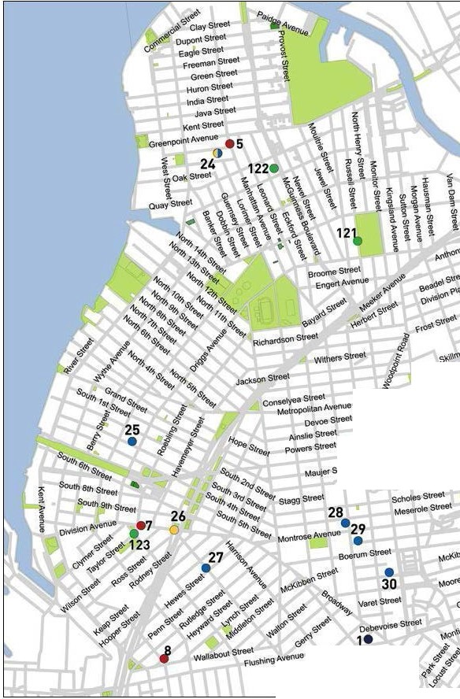

c

HoPKtrlS S\ree\
•9
EllC<'lstroel

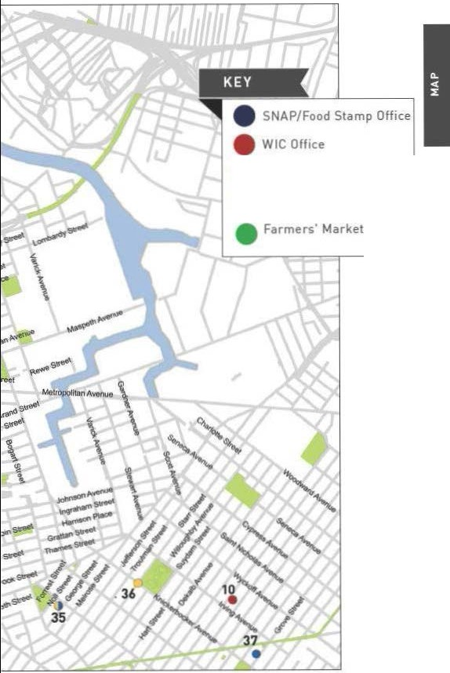

  - Soup Kitchen
  - Food Pantry

II
I
l •8 "

1•33
'\
48

\
.
!l.

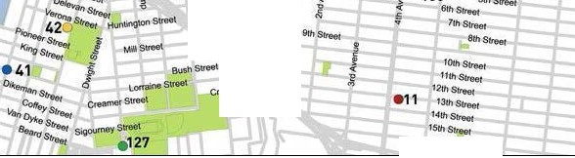
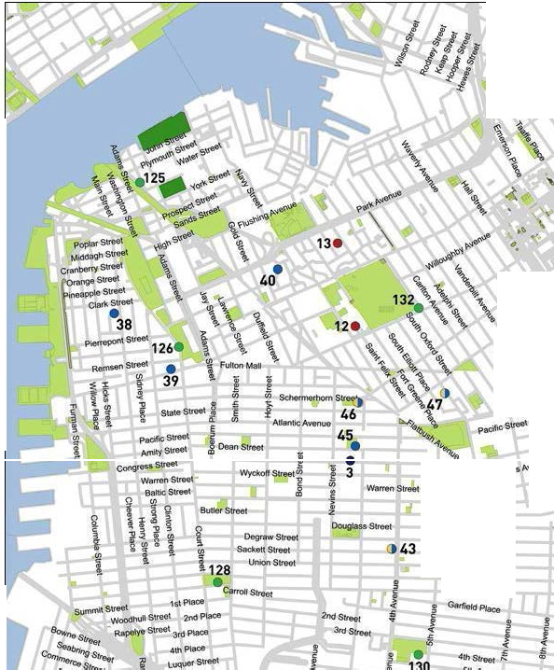
()
). 49

sa'int•"'
.44
Stetling PJaoe
SaintJrchns P-tao& Wnoo1nPfac41 8o<1<eley
Pr .UniiMStn!et esident su.t

we.t91l\Stfe8t
G:.rnet
Centte
I

ccearnetStroet./
:2

16rhSfreet

1•6


<»68

\ 11•
\
•79

1
•78 \
80
lit


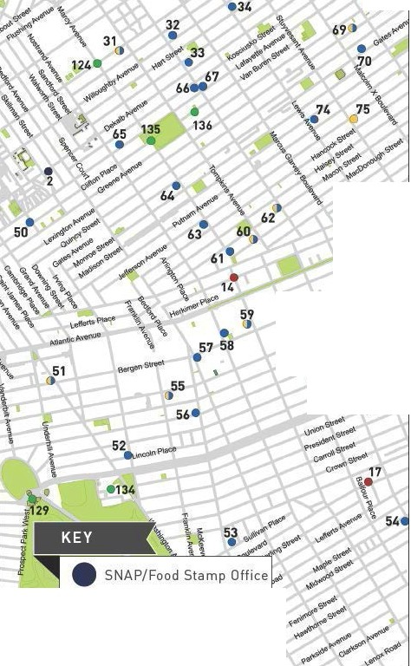
8•1

- W I C Off ice

Sou p Kitchen

- Food Pa ntry

- Fa rmers' Market
31 II

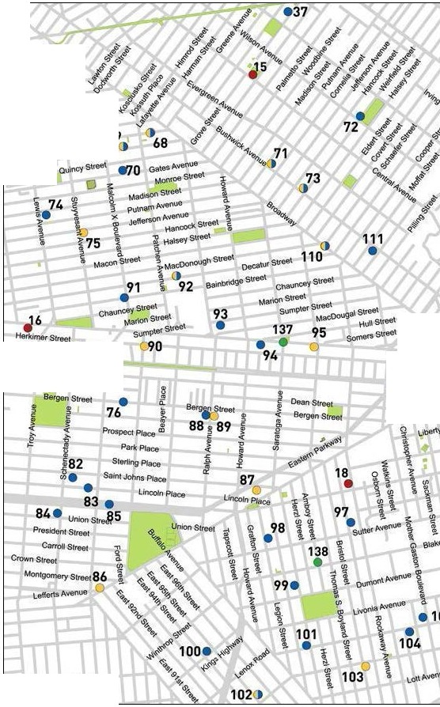
34
- Hansueel
pul.8Sk1St Qe\1.8.\bAvee l(o<cl1J$\<Osuec\
utayet\e MeNJf!
vatt6U(e0suee\ 69
Grecr;O"""""' G

Atlantic AVenUe I
Dean S<reet Pacifoc Sbeet • t
96

WlfllhlOP Street
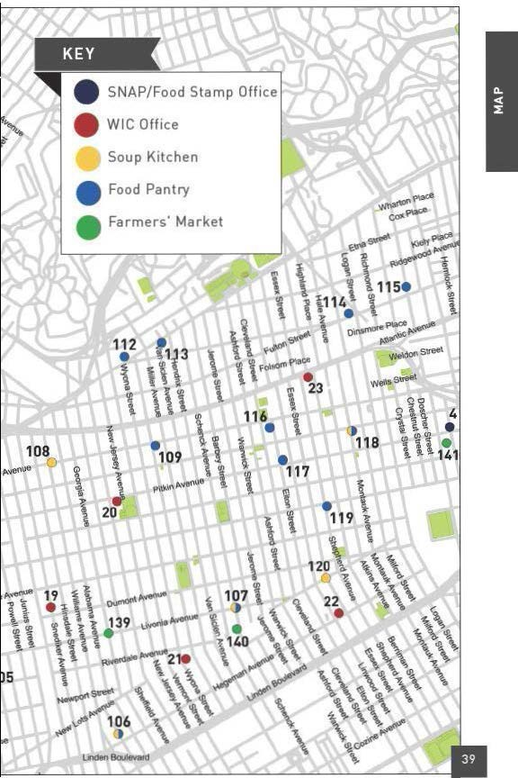
Feel free to use t his space for your own notes.

IINe ighborhood Guide to Food and Assistance - Upper Brooklyn Edition


Neig hborhood Guide to Food and Assistance - Upper Brooklyn Editi on II
OTHER ASSISTANCE
Additional organizations in your neighborhood that can as- sist you with matters other than food support.

MEDICAL CARE

Woodhull Medical Center
760 Broadway, 11206
718 963 8000
kings County Hospital Center
451 Clarkson Ave., 11203
718 245 3131
Williamsburg Health Center
279 Graham Ave., 11211
718 384 0563
east new york Health Center
2094 Pitkin Ave., 11207
718 240 0400
Wyckoff Heights Medical Center
374 Stockholm St., 11237
718 963 7272
Fort Greene Health Center
295 Flatbush Ave Extension, 11201
718 388 0601

HEALTH INSURANCE

Affinity Health System
Information regarding health insurance, including enrollment in Medicaid, Medicare and other plans.
General Info 866 694 9809
1684 Pitkin Ave.,11212

Neighborhood Guide to Food and Assistance - Upper Brooklyn edition
42

Provides specific and detailed assistance regarding a wide range of legal topics, including agencies that might be able to help you find an attorney to represent you in court.
LEGAL ASSISTANCE
The City Bar Justice Hotline
212 626 7383
Mon–Thu 9am-5pm, Fri 9am-1pm
Free, basic legal advice on a range of civil issues. Will not provide an attorney or assist with in-court representation.
X
MORE HELP
EMERGENCY NUMBERS

National Hunger Hotline 866 3-HUNGRY (866 348 6479)
NYC Hunger Hotline 866 888 8777 Police, Fire or Ambulance: 911 Emergency Shelter: 311
Homeless Hotline: 800 994 6494, 212 533 5151
Immigration Hotline: 212 419 3737, 800 566 7636
Center for Disease Control: 800 232 4636
Poison Control: 800 222 1222
AIDS Hotline: 800 541 AIDS, 800 233 7432 (Spanish)
Alcoholics Anonymous: 212 647 1680
Narcotics Anonymous: 212 929 6262
Gamblers Anonymous Hotline: 855 222 5542
Domestic Violence Hotline: 800 621 4673
Battered Women Hotline: 718 499 2151
Rape & Sexual Assault Hotline: 212 423 2140, 212 227 3000
Child Abuse Hotline: 800 342 3720
Runaway Hotline: 800 786 2929 (800 RUN AWAY)
Crime Victim Hotline: 212 577 7777, 800 689 4357
Suicide Hotline: 800 273 8255
National Crisis Line: 800 999 9999

Credits: Icons adapted from The Noun Project collection. Map data © OpenStreet- Map contributors.

Neighborhood Guide to Food and Assistance - Upper Brooklyn edition
43
WHAT AM I ELIG IBLE FOR ?

Use the chart below to see what programs may be available for you and your family.


PEOPLE WITH CHILDREN
e CD 0
e 0

PEOPLE WITHOUT CHILDREN
e m 0

SENIOR CITIZENS
e CD 0

HOMELESS INDIVIDUALS

LEGAL IMMIGRANTS
e CD 0

UNDOCUMENTED IMMIGRANTS
() 0

- SNAP/ Food Stamp 0Groceries at Food Pantries WIC Packages
'1Benefits
"" School Breakfast & Lunch - Meals at Soup Kitchens
W Free Summer Meals
for Children
Meals at Senior Centers
'ii Home-delivered Meals
-l lYN&ER

FREE
NYC
Have any suggestions on how to make this Guide better? Email gu ideslahu ngerf reenyc.org.

